NYQUIST SAMPLING THEOREM
code:
import pygame
import sys
import math

# -----------------------------
# USER INPUT
# -----------------------------
fs = float(input("Enter sampling frequency fs (Hz): "))

# -----------------------------
# SIGNAL PARAMETERS
# -----------------------------
fmax = 4.0 # sin(8πt)
Ts = 1 / fs
TIME_WINDOW = 1.0
WIDTH = 1000
HEIGHT = 1000
AMPLITUDE = 90
FPS = 60

# -----------------------------
# COLORS
# -----------------------------
WHITE = (255, 255, 255)
BLACK = (0, 0, 0)
RED = (255, 0, 0) # Original
BLUE = (0, 0, 255) # Sampled
GREEN = (0, 180, 0) # Reconstructed
GRAY = (150, 150, 150)

# -----------------------------
# SIGNAL FUNCTIONS
# -----------------------------
def original_signal(t):
return math.sin(8 * math.pi * t)

def sinc(x):
return 1 if x == 0 else math.sin(math.pi * x) / (math.pi * x)

def reconstruct(t, samples):
y = 0
for tn, xn in samples:
y += xn * sinc((t - tn) / Ts)
return y

# -----------------------------
# PYGAME INIT
# -----------------------------
pygame.init()
screen = pygame.display.set_mode((WIDTH, HEIGHT))
pygame.display.set_caption("Nyquist Sampling Theorem")
clock = pygame.time.Clock()
font = pygame.font.SysFont("Arial", 18)

center_top = HEIGHT // 4
center_bottom = 3 * HEIGHT // 4

# -----------------------------
# CREATE SAMPLES
# -----------------------------
samples = []
n = 0
while n * Ts <= TIME_WINDOW:
t = n * Ts
samples.append((t, original_signal(t)))
n += 1

# -----------------------------
# MAIN LOOP
# -----------------------------
while True:
clock.tick(FPS)

for event in pygame.event.get():
if event.type == pygame.QUIT:
pygame.quit()
sys.exit()

screen.fill(WHITE)

# -----------------------------
# Original signal (TOP)
# -----------------------------
orig_points = []
for x in range(WIDTH):
t = (x / WIDTH) * TIME_WINDOW
y = original_signal(t)
orig_points.append((x, center_top - int(y * AMPLITUDE)))
pygame.draw.lines(screen, RED, False, orig_points, 2)

pygame.draw.line(screen, GRAY, (0, center_top), (WIDTH, center_top), 1)

# -----------------------------
# Sampled signal (BOTTOM - stems)
# -----------------------------
pygame.draw.line(screen, GRAY, (0, center_bottom), (WIDTH, center_bottom), 1)

for t, y in samples:
sx = int((t / TIME_WINDOW) * WIDTH)
sy = center_bottom - int(y * AMPLITUDE)
pygame.draw.line(screen, BLUE, (sx, center_bottom), (sx, sy), 2)
pygame.draw.circle(screen, BLUE, (sx, sy), 4)

# -----------------------------
# Reconstructed signal (TOP)
# -----------------------------
recon_points = []
for x in range(WIDTH):
t = (x / WIDTH) * TIME_WINDOW
y = reconstruct(t, samples)
recon_points.append((x, center_top - int(y * AMPLITUDE)))
pygame.draw.lines(screen, GREEN, False, recon_points, 2)

# -----------------------------
# TEXT INFO
# -----------------------------
info = [
"Original Signal: sin(8πt)",
f"fmax = {fmax} Hz",
f"fs = {fs} Hz",
f"fs / fmax = {fs / fmax:.2f}",
"Reconstruction OK" if fs >= 2*fmax else "Aliasing Occurs"
]

for i, text in enumerate(info):
screen.blit(font.render(text, True, BLACK), (10, 10 + 20*i))

pygame.display.flip()
Output:
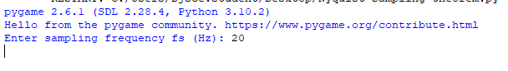
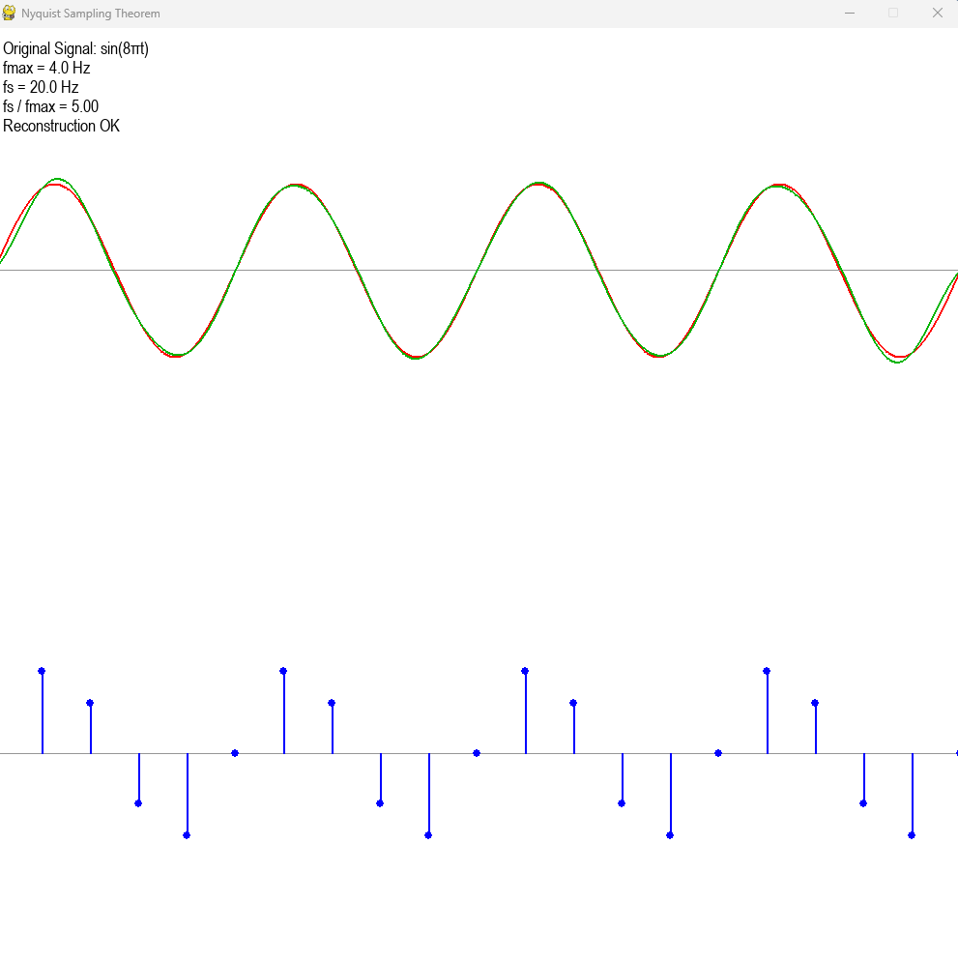
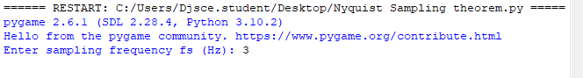
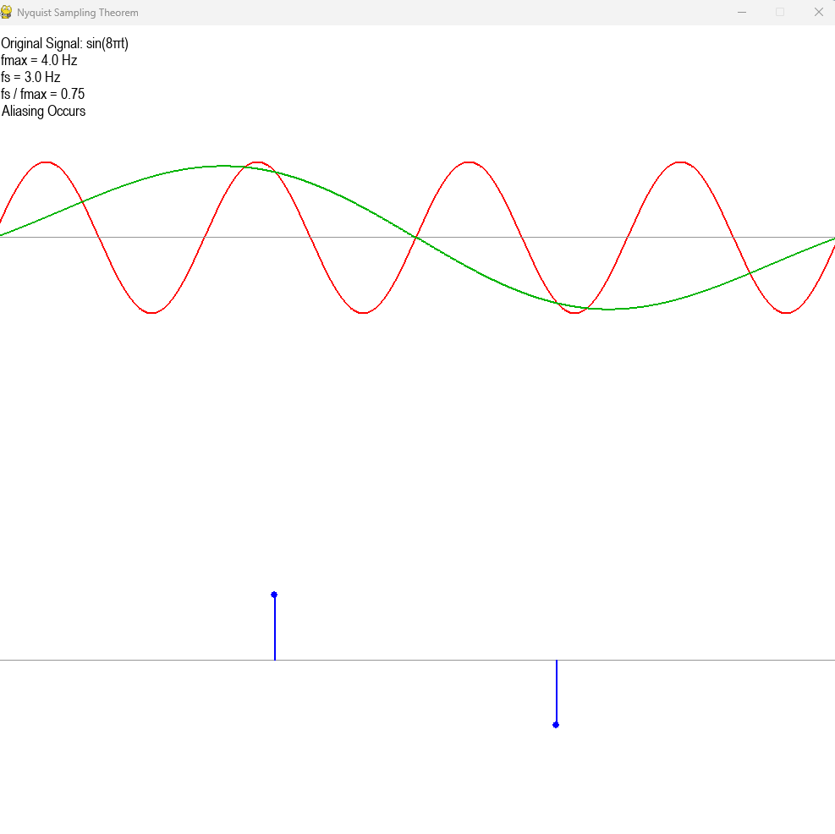
Operations on samples
Code:
import pygame
import sys

# -----------------------------
# PYGAME SETUP
# -----------------------------
WIDTH = 1000
HEIGHT = 1000
WHITE = (255, 255, 255)
BLACK = (0, 0, 0)
RED = (255, 0, 0)
BLUE = (0, 0, 255)

pygame.init()
screen = pygame.display.set_mode((WIDTH, HEIGHT))
pygame.display.set_caption("Discrete-Time Signal Operations")
font = pygame.font.SysFont("Arial", 16)
clock = pygame.time.Clock()

# -----------------------------
# DRAW STEM PLOT
# -----------------------------
def draw_signal(n, x, center_y, color, label):
pygame.draw.line(screen, BLACK, (50, center_y), (WIDTH-50, center_y), 2)
pygame.draw.line(screen, BLACK, (WIDTH//2, 50), (WIDTH//2, HEIGHT-50), 2)

screen.blit(font.render(label, True, BLACK), (50, center_y - 150))

scale_x = 60
origin_x = WIDTH // 2
origin_y = center_y

if not x:
return

max_val = max(abs(val) for val in x)

for ni, xi in zip(n, x):
px = origin_x + ni * scale_x
py = origin_y - xi * 20

pygame.draw.line(screen, color, (px, origin_y), (px, py), 2)
pygame.draw.circle(screen, color, (px, py), 4)

screen.blit(font.render(str(xi), True, BLACK), (px - 10, py - 20))
screen.blit(font.render(str(ni), True, BLACK), (px - 10, origin_y + 5))

for y_val in range(-max_val-1, max_val+2):
py = origin_y - y_val * 20
if 0 < py < HEIGHT:
screen.blit(font.render(str(y_val), True, BLACK), (origin_x - 40, py - 5))

# -----------------------------
# USER INPUT
# -----------------------------
x = list(map(int, input("Enter discrete signal x(n) (space separated): ").split()))
origin_index = int(input(f"Enter index of origin (n=0) in range 0..{len(x)-1}: "))

n = [i - origin_index for i in range(len(x))]

print("\nMENU")
print("1. Time Shifting")
print("2. Time Reversal")
print("3. Time Reversal + Shifting")
print("4. Time Scaling")
print("5. Scalar Multiplication")
print("6. Addition of Two Signals")
print("7. Subtraction of Two Signals")
print("8. Multiplication of Two Signals")

choice = int(input("Enter your choice: "))

# -----------------------------
# OPERATIONS
# -----------------------------
if choice == 1:
k = int(input("Enter shift value k: "))
y = x[:]
n2 = [i + k for i in n]
title = f"Time Shifted (k = {k})"

elif choice == 2:
y = x[::-1]
n2 = [-i for i in n[::-1]]
title = "Time Reversed"

elif choice == 3:
k = int(input("Enter shift value k: "))
y = x[::-1]
n2 = [-(i) + k for i in n[::-1]]
title = f"Time Reversed + Shifted (k = {k})"

elif choice == 4:
a = int(input("Enter scaling factor a: "))
y = x[:]
n2 = [i * a for i in n]
title = f"Time Scaled (a = {a})"

elif choice == 5:
a = int(input("Enter scalar value: "))
y = [a * i for i in x]
n2 = n[:]
title = f"Scalar Multiplied (A = {a})"

elif choice in [6, 7, 8]:

print("\nEnter second signal x2(n)")
x2 = list(map(int, input("Enter discrete signal x2(n): ").split()))
origin_index2 = int(input(f"Enter index of origin for x2(n) 0..{len(x2)-1}: "))
n_second = [i - origin_index2 for i in range(len(x2))]

# Create common time axis WITHOUT modifying original x
n_min = min(min(n), min(n_second))
n_max = max(max(n), max(n_second))
n2 = list(range(n_min, n_max + 1))

# Create dictionaries for fast lookup
dict1 = dict(zip(n, x))
dict2 = dict(zip(n_second, x2))

y = []
for ni in n2:
val1 = dict1.get(ni, 0)
val2 = dict2.get(ni, 0)

if choice == 6:
y.append(val1 + val2)
title = "Addition: x(n) + x2(n)"

elif choice == 7:
y.append(val1 - val2)
title = "Subtraction: x(n) - x2(n)"

elif choice == 8:
y.append(val1 * val2)
title = "Multiplication: x(n) * x2(n)"

else:
print("Invalid choice")
pygame.quit()
sys.exit()

# -----------------------------
# PRINT RESULTS
# -----------------------------
print("\nOriginal Signal:")
print("n:", n)
print("x(n):", x)

print("\nProcessed Signal:")
print("n:", n2)
print("y(n):", y)

# -----------------------------
# DISPLAY LOOP
# -----------------------------
while True:
clock.tick(60)

for event in pygame.event.get():
if event.type == pygame.QUIT:
pygame.quit()
sys.exit()

screen.fill(WHITE)

draw_signal(n, x, HEIGHT//3, RED, "Original Signal x(n)")
draw_signal(n2, y, 2*HEIGHT//3, BLUE, title)

pygame.display.flip()

import pygame
import sys

# -----------------------------
# PYGAME SETUP
# -----------------------------
WIDTH = 1000
HEIGHT = 1000
WHITE = (255, 255, 255)
BLACK = (0, 0, 0)
RED = (255, 0, 0)
BLUE = (0, 0, 255)

pygame.init()
screen = pygame.display.set_mode((WIDTH, HEIGHT))
pygame.display.set_caption("Discrete-Time Signal Operations")
font = pygame.font.SysFont("Arial", 16)
clock = pygame.time.Clock()

# -----------------------------
# DRAW STEM PLOT
# -----------------------------
def draw_signal(n, x, center_y, color, label):
pygame.draw.line(screen, BLACK, (50, center_y), (WIDTH-50, center_y), 2)
pygame.draw.line(screen, BLACK, (WIDTH//2, 50), (WIDTH//2, HEIGHT-50), 2)

screen.blit(font.render(label, True, BLACK), (50, center_y - 150))

scale_x = 60
origin_x = WIDTH // 2
origin_y = center_y

if not x:
return

max_val = max(abs(val) for val in x)

for ni, xi in zip(n, x):
px = origin_x + ni * scale_x
py = origin_y - xi * 20

pygame.draw.line(screen, color, (px, origin_y), (px, py), 2)
pygame.draw.circle(screen, color, (px, py), 4)

screen.blit(font.render(str(xi), True, BLACK), (px - 10, py - 20))
screen.blit(font.render(str(ni), True, BLACK), (px - 10, origin_y + 5))

for y_val in range(-max_val-1, max_val+2):
py = origin_y - y_val * 20
if 0 < py < HEIGHT:
screen.blit(font.render(str(y_val), True, BLACK), (origin_x - 40, py - 5))

# -----------------------------
# USER INPUT
# -----------------------------
x = list(map(int, input("Enter discrete signal x(n) (space separated): ").split()))
origin_index = int(input(f"Enter index of origin (n=0) in range 0..{len(x)-1}: "))

n = [i - origin_index for i in range(len(x))]

print("\nMENU")
print("1. Time Shifting")
print("2. Time Reversal")
print("3. Time Reversal + Shifting")
print("4. Time Scaling")
print("5. Scalar Multiplication")
print("6. Addition of Two Signals")
print("7. Subtraction of Two Signals")
print("8. Multiplication of Two Signals")

choice = int(input("Enter your choice: "))

# -----------------------------
# OPERATIONS
# -----------------------------
if choice == 1:
k = int(input("Enter shift value k: "))
y = x[:]
n2 = [i + k for i in n]
title = f"Time Shifted (k = {k})"

elif choice == 2:
y = x[::-1]
n2 = [-i for i in n[::-1]]
title = "Time Reversed"

elif choice == 3:
k = int(input("Enter shift value k: "))
y = x[::-1]
n2 = [-(i) + k for i in n[::-1]]
title = f"Time Reversed + Shifted (k = {k})"

elif choice == 4:
a = int(input("Enter scaling factor a: "))
y = x[:]
n2 = [i * a for i in n]
title = f"Time Scaled (a = {a})"

elif choice == 5:
a = int(input("Enter scalar value: "))
y = [a * i for i in x]
n2 = n[:]
title = f"Scalar Multiplied (A = {a})"

elif choice in [6, 7, 8]:

print("\nEnter second signal x2(n)")
x2 = list(map(int, input("Enter discrete signal x2(n): ").split()))
origin_index2 = int(input(f"Enter index of origin for x2(n) 0..{len(x2)-1}: "))
n_second = [i - origin_index2 for i in range(len(x2))]

# Create common time axis WITHOUT modifying original x
n_min = min(min(n), min(n_second))
n_max = max(max(n), max(n_second))
n2 = list(range(n_min, n_max + 1))

# Create dictionaries for fast lookup
dict1 = dict(zip(n, x))
dict2 = dict(zip(n_second, x2))

y = []
for ni in n2:
val1 = dict1.get(ni, 0)
val2 = dict2.get(ni, 0)

if choice == 6:
y.append(val1 + val2)
title = "Addition: x(n) + x2(n)"

elif choice == 7:
y.append(val1 - val2)
title = "Subtraction: x(n) - x2(n)"

elif choice == 8:
y.append(val1 * val2)
title = "Multiplication: x(n) * x2(n)"

else:
print("Invalid choice")
pygame.quit()
sys.exit()

# -----------------------------
# PRINT RESULTS
# -----------------------------
print("\nOriginal Signal:")
print("n:", n)
print("x(n):", x)

print("\nProcessed Signal:")
print("n:", n2)
print("y(n):", y)

# -----------------------------
# DISPLAY LOOP
# -----------------------------
while True:
clock.tick(60)

for event in pygame.event.get():
if event.type == pygame.QUIT:
pygame.quit()
sys.exit()

screen.fill(WHITE)

draw_signal(n, x, HEIGHT//3, RED, "Original Signal x(n)")
draw_signal(n2, y, 2*HEIGHT//3, BLUE, title)

pygame.display.flip()

Output:
